DLB Lab -2

Tasks

Roll no: 23K-2001
BCS 2-J

Exercise # 01: Y = A+B’
INPUT (A) | INPUT (B) | OUTPUT (Y)
0 | 0 | 1
0 | 1 | 0
1 | 0 | 1
1 | 1 | 1

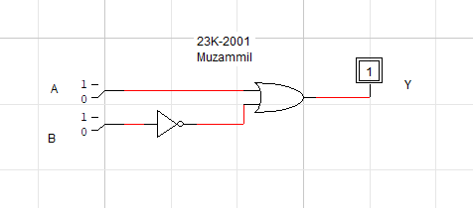
Exercise #02: F = X’Y+XZ
Input (X) | Input (Y) | Input (Z) | Output (F)
0 | 0 | 0 | 0
0 | 0 | 1 | 0
0 | 1 | 0 | 1
0 | 1 | 1 | 1
1 | 0 | 0 | 0
1 | 0 | 1 | 1
1 | 1 | 0 | 0
1 | 1 | 1 | 1
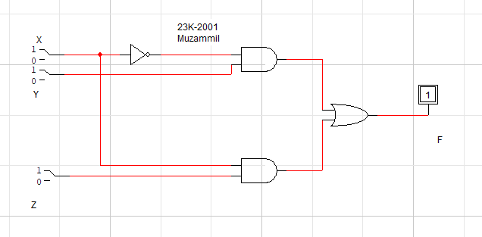

Exercise #03: F = ((AB + CD)’ + B’)(C’)
Input (A) | Input (B) | Input (C) | Input (D) | Output (F)
0 | 0 | 0 | 0 | 1
0 | 0 | 0 | 1 | 1
0 | 0 | 1 | 0 | 0
0 | 0 | 1 | 1 | 0
0 | 1 | 0 | 0 | 1
0 | 1 | 0 | 1 | 1
0 | 1 | 1 | 0 | 0
0 | 1 | 1 | 1 | 0
1 | 0 | 0 | 0 | 1
1 | 0 | 0 | 1 | 1
1 | 0 | 1 | 0 | 0
1 | 0 | 1 | 1 | 0
1 | 1 | 0 | 0 | 0
1 | 1 | 0 | 1 | 0
1 | 1 | 1 | 0 | 0
1 | 1 | 1 | 1 | 0
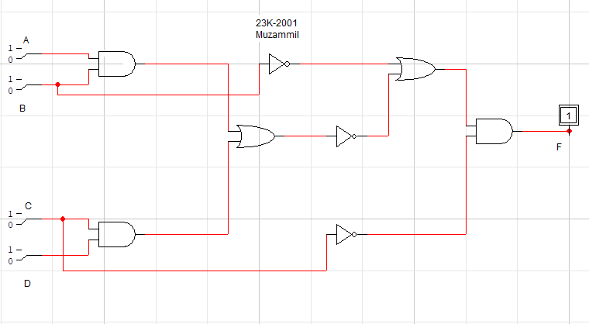

Exercise #04:

- F = A+A’B

Input A | Input B | Output F
0 | 0 | 0
0 | 1 | 1
1 | 0 | 1
1 | 1 | 1

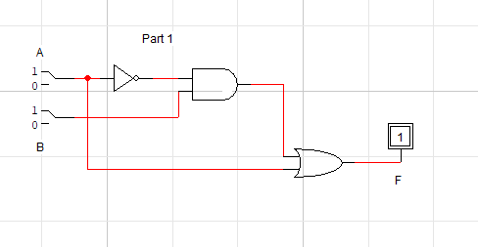

- F = (A+B)(A+C)

Input A | Input B | Input C | Output F
0 | 0 | 0 | 0
0 | 0 | 1 | 0
0 | 1 | 0 | 0
0 | 1 | 1 | 1
1 | 0 | 0 | 1
1 | 0 | 1 | 1
1 | 1 | 0 | 1
1 | 1 | 1 | 1
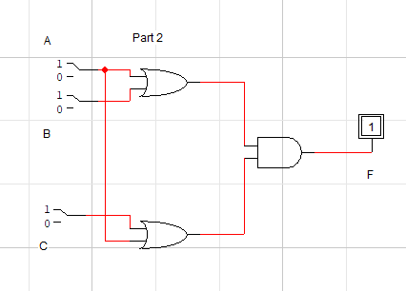

- F = A(B+CD)
3. F = A(B+CD)
Input A | Input B | Input C | Input D | Output F
0 | 0 | 0 | 0 | 0
0 | 0 | 0 | 1 | 0
0 | 0 | 1 | 0 | 0
0 | 0 | 1 | 1 | 0
0 | 1 | 0 | 0 | 0
0 | 1 | 0 | 1 | 0
0 | 1 | 1 | 0 | 0
0 | 1 | 1 | 1 | 0
1 | 0 | 0 | 0 | 0
1 | 0 | 0 | 1 | 0
1 | 0 | 1 | 0 | 0
1 | 0 | 1 | 1 | 1
1 | 1 | 0 | 0 | 1
1 | 1 | 0 | 1 | 1
1 | 1 | 1 | 0 | 1
1 | 1 | 1 | 1 | 1
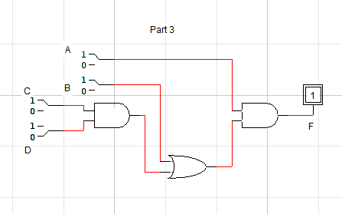
- F = AB + A(B+C)+(B+C)
Input A | Input B | Input C | Output F
0 | 0 | 0 | 0
0 | 0 | 1 | 1
0 | 1 | 0 | 1
0 | 1 | 1 | 1
1 | 0 | 0 | 0
1 | 0 | 1 | 1
1 | 1 | 0 | 1
1 | 1 | 1 | 1

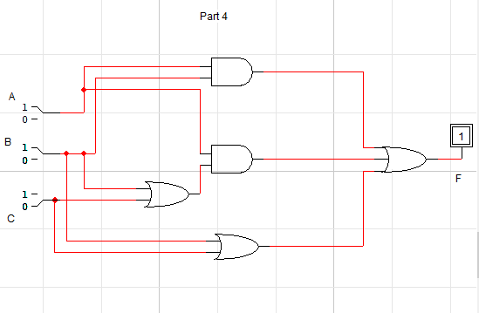

- F = X(YZ) + X’Y + (XY)Z’
Input X | Input Y | Input Z | Output F
0 | 0 | 0 | 0
0 | 0 | 1 | 0
0 | 1 | 0 | 1
0 | 1 | 1 | 1
1 | 0 | 0 | 0
1 | 0 | 1 | 0
1 | 1 | 0 | 1
1 | 1 | 1 | 1

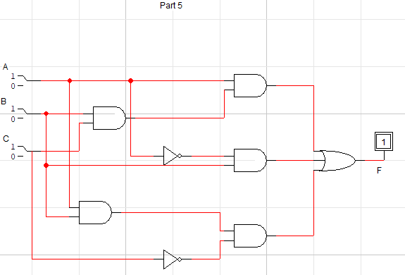

- F = B’C + AC’
Input A | Input B | Input C | Output F
0 | 0 | 0 | 0
0 | 0 | 1 | 1
0 | 1 | 0 | 0
0 | 1 | 1 | 0
1 | 0 | 0 | 1
1 | 0 | 1 | 1
1 | 1 | 0 | 1
1 | 1 | 1 | 0
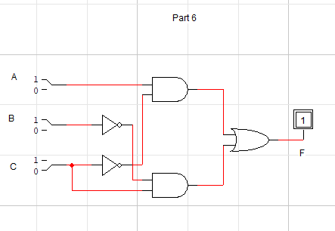

- F = X’ + Y’Z
Input X | Input Y | Input Z | Output F
0 | 0 | 0 | 1
0 | 0 | 1 | 1
0 | 1 | 0 | 1
0 | 1 | 1 | 1
1 | 0 | 0 | 0
1 | 0 | 1 | 1
1 | 1 | 0 | 0
1 | 1 | 1 | 0
